ACIT 1630

Relational Database Design and SQL

Review Questions

Lesson 1

Answer each of the following questions labeling your answers clearly. Save your work in the Desire2Learn **Drop box** for **Lesson 01 – Review Questions**.

1. Discuss each of the following terms:
   1. data – Data is raw or unchanged facts that once processed can be interpreted or processed become information.
   2. field – One or more characters that have a specific meaning, used to store identify, and store data.
   3. record – A logically connected set of one or more fields that describes a person, place or thing.
   4. file – A collection of related records. Ex: file contains data about the students enrolled at a university.
2. What is data redundancy, and which characteristics of the file system can lead to it?

Data redundancy is when certain data exist in more than one place. This occurs when data is separated into islands of information where data could be updated inconsistently creating duplicate data.

1. What is data independence, and why is it lacking in file systems?

Data independence is when a data’s storage can be changed without affecting the data itself. File systems are affected by system changes because within a file system the file tells the computer not only what to do but how to do it.

1. What is a Database Management System (DBMS)?

A DBMS is one of several crucial parts of a database. Its job is to act like the heart of the

1. What is structural independence, and why is it important?
2. Explain the difference between data, information, and a database.
3. What is the role of a DBMS, and what are its advantages? What are its disadvantages?
4. List and describe the different types of databases.
5. What are the main components of a database system?
6. What is metadata?
7. Explain why database design is important.
8. What are the potential costs of implementing a database system?
9. Use examples to compare and contrast unstructured and structured data. Which type is more prevalent in a typical business environment?
10. What are some basic database functions that a spreadsheet cannot perform?
11. What common problems do a collection of spreadsheets created by end users share with the typical file system?
12. Explain the significance of the loss of direct, hands-on access to business data that users experienced with the advent of computerized data repositories.
13. Explain why the cost of ownership may be lower with a cloud database than with a traditional, company database.

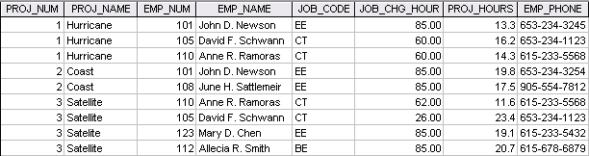

1. Identify and discuss the serious data redundancy problems exhibited by the above file structure.
2. In the file structure above, looking at the EMP_NAME and EMP_PHONE contents, what change(s) would you recommend?
3. Identify the various data sources in the above file structure